Project Design Phase-II
Data Flow Diagram & User Stories

Date | 31 January 2025
Team ID | SWTID-2026-9910
Project Name | MediConnect – Smart Doctor Appointment Booking System
Maximum Marks | 4 Marks

Data Flow Diagrams:
A Data Flow Diagram (DFD) is a traditional visual representation of the information flows within a system. A neat and clear DFD can depict the right amount of the system requirement graphically. It shows how data enters and leaves the system, what changes the information, and where data is stored.
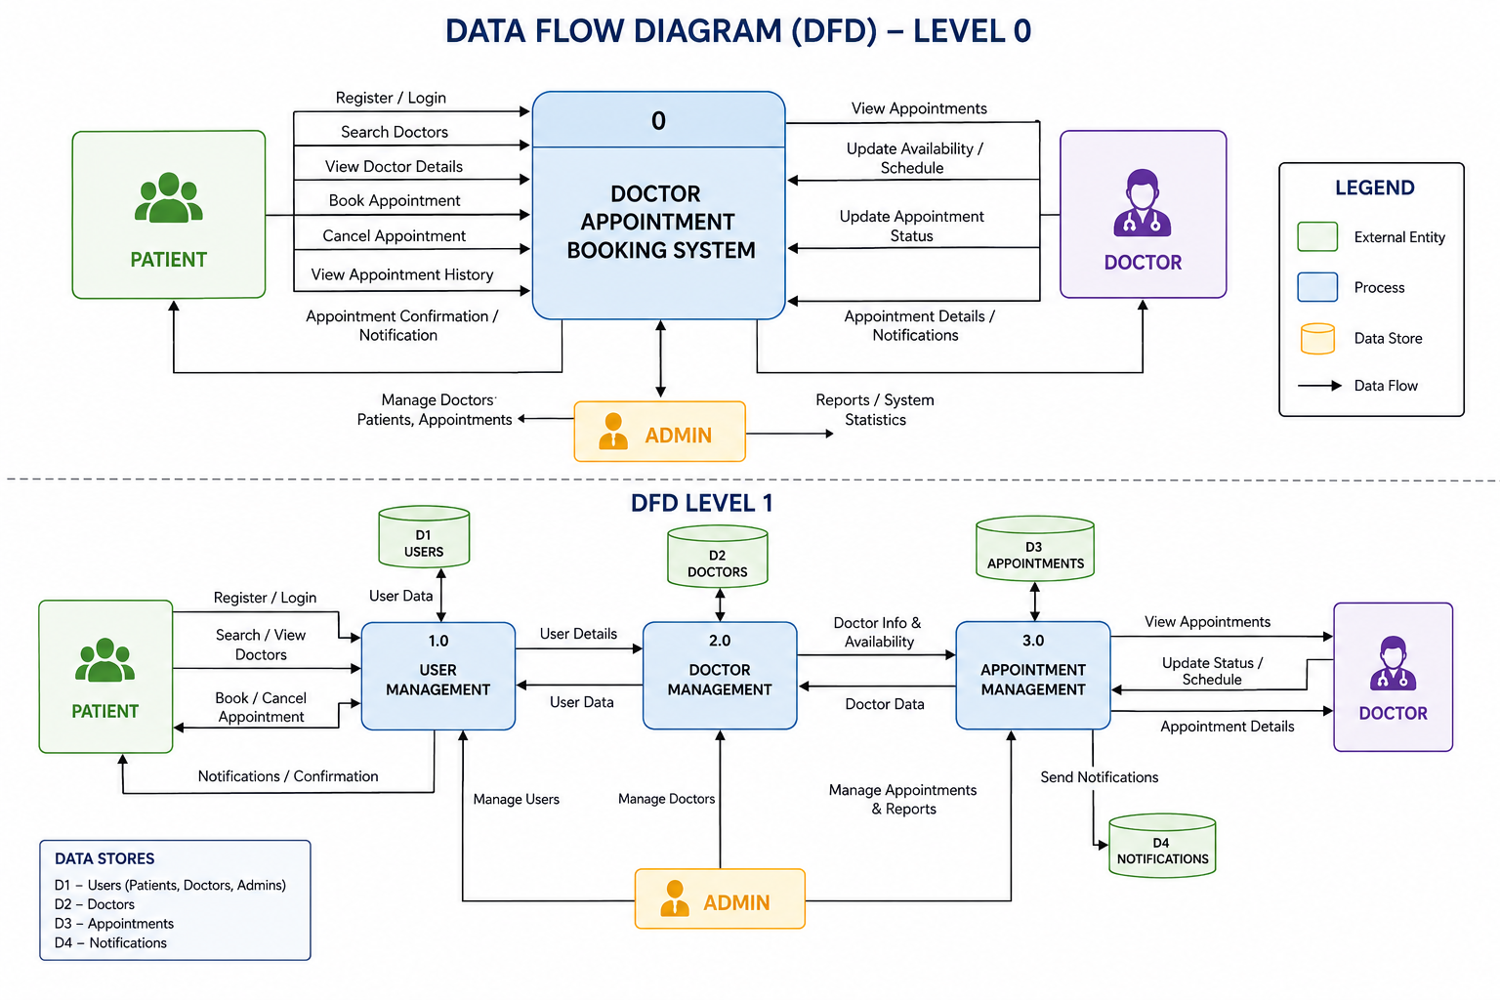

User Stories
Use the below template to list all the user stories for the product.
User Type | Functional Requirement (Epic) | User Story Number | User Story / Task | Acceptance Criteria | Priority | Release
Patient | Registration | USN-1 | As a patient, I can register using my name, email, phone number, and password. | Patient account is created successfully and user can log in. | High | Sprint-1
Patient | Login | USN-2 | As a patient, I can log in using my email and password. | Patient is redirected to the dashboard after successful login. | High | Sprint-1
Patient | Profile Management | USN-3 | As a patient, I can update my profile information. | Updated profile details are saved successfully. | Medium | Sprint-1
Patient | Doctor Search | USN-4 | As a patient, I can search doctors based on specialization. | Relevant doctors are displayed based on search criteria. | High | Sprint-1
Patient | View Doctor Details | USN-5 | As a patient, I can view doctor profiles and availability. | Doctor details and available slots are displayed correctly. | High | Sprint-1
Patient | Appointment Booking | USN-6 | As a patient, I can book an appointment with a doctor. | Appointment is confirmed and stored in the database. | High | Sprint-2
Patient | Appointment History | USN-7 | As a patient, I can view all my booked appointments. | Previous and upcoming appointments are displayed. | Medium | Sprint-2
Patient | Cancel Appointment | USN-8 | As a patient, I can cancel a booked appointment. | Appointment status changes to cancelled. | Medium | Sprint-2
Doctor | Login | USN-9 | As a doctor, I can securely log in to my account. | Doctor dashboard is accessible after successful login. | High | Sprint-1
Doctor | Manage Schedule | USN-10 | As a doctor, I can manage my availability and consultation timings. | Updated schedule is reflected in appointment booking. | High | Sprint-2
Doctor | View Appointments | USN-11 | As a doctor, I can view today's and upcoming appointments. | Appointment list is displayed accurately. | High | Sprint-2
Doctor | Update Appointment Status | USN-12 | As a doctor, I can mark appointments as completed or cancelled. | Appointment status is updated successfully. | Medium | Sprint-2
Administrator | Admin Login | USN-13 | As an administrator, I can securely log in to the system. | Admin dashboard opens after successful authentication. | High | Sprint-1
Administrator | Manage Doctors | USN-14 | As an administrator, I can add, edit, or remove doctor profiles. | Doctor information is updated successfully in the system. | High | Sprint-2
Administrator | Manage Patients | USN-15 | As an administrator, I can view and manage registered patients. | Patient records are displayed and managed successfully. | Medium | Sprint-2
Administrator | Manage Appointments | USN-16 | As an administrator, I can monitor and manage all appointments. | Appointment records are updated and managed correctly. | High | Sprint-2
Administrator | Dashboard Analytics | USN-17 | As an administrator, I can view statistics of doctors, patients, and appointments. | Dashboard displays accurate system statistics. | Low | Sprint-3
System | Notifications | USN-18 | As a system, I notify users about successful appointment bookings. | Confirmation message is displayed or sent after booking. | Medium | Sprint-3

